E-COMMERCE SALES ANALYSIS USING POWER BI AND DAX
Submitted By
Name: Hema Ishwarya C
Course: AI Driven Data Analytics
Tool Used: Microsoft Power BI Desktop

ABSTRACT:
The purpose of this project is to analyze an E-Commerce Sales Dataset using Microsoft Power BI and DAX (Data Analysis Expressions). The project focuses on understanding sales performance, profitability, target achievement, and customer purchasing trends through interactive dashboards and analytical visualizations.
Various DAX calculations and business metrics were developed to generate meaningful insights that can support business decision-making. The dashboard provides a comprehensive overview of category performance, monthly sales trends, geographical distribution, and profitability analysis.

OBJECTIVES:
The main objectives of this project are:
- To perform sales analysis using Power BI.
- To create calculated columns and measures using DAX.
- To compare actual sales against sales targets.
- To identify profitable categories and sub-categories.
- To analyze monthly and regional sales performance.
- To develop an interactive dashboard for business decision-making.

DATASET DESCRIPTION:
The project uses three datasets:
1. List of Orders:
Contains information about customer orders.
Attributes:
- Order ID
- Order Date
- Customer Name
- City
- State
- Category
- Amount
- Profit

2. Order Details:
Contains product-level transaction details.
Attributes:
- Order ID
- Category
- Sub-Category
- Quantity
- Amount
- Profit

3. Sales Target:
Contains monthly sales targets for each category.
Attributes:
- Category
- Month of Order Date
- Target

DATA MODELING
Relationships were established between the three datasets to enable accurate calculations and reporting. Proper data modelling ensures consistency and allows users to perform advanced business analysis using DAX.

DAX CALCULATIONS
1. Category Type (Calculated Column)
Formula: Category Type = [Category] & " - " & [Sub-Category]
Description:
This column combines Category and Sub-Category into a single field.
Business Benefit:
Provides better product classification and improves filtering and reporting.
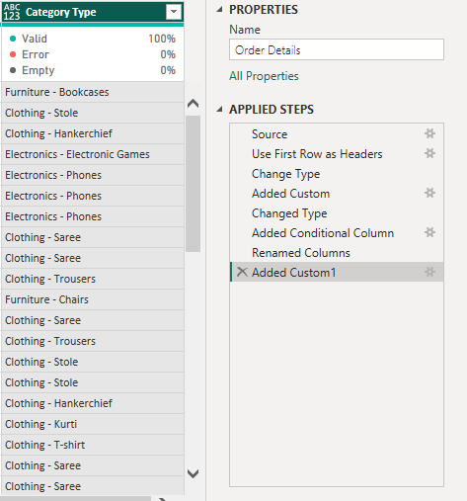

2. Revenue (Calculated Column):
Formula: Revenue = [Amount] * [Quantity]
Description:
Calculates the revenue generated by each order.
Business Benefit:
Helps identify high-value transactions and their contribution to total revenue.

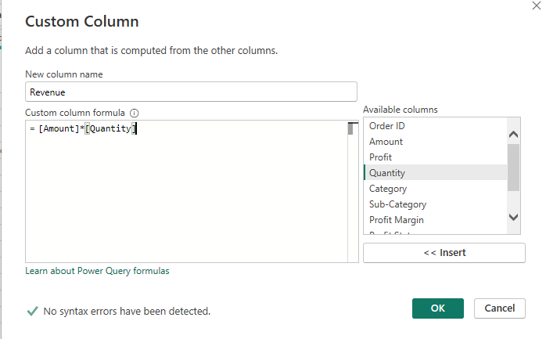

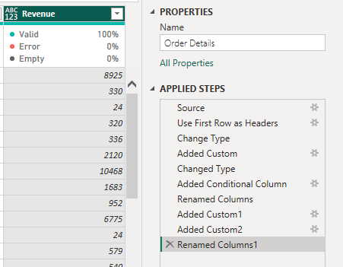

3. Sales Category (Calculated Column):
Formula: Sales Category =
IF(
'Order Details'[Revenue] > AVERAGE ('Order Details'[Revenue]),
"Above Average",
"Below Average"
)

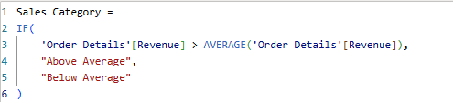

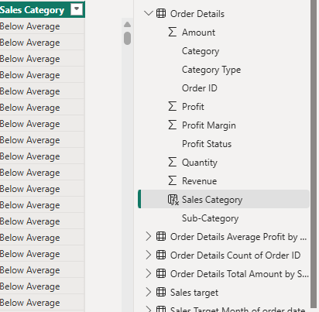

Description:
Categorizes orders as "Above Average" or "Below Average" based on revenue.
Business Benefit:
Helps identify high-performing and low-performing orders.

4. Order Count (Measure):
Formula: Order Count = DISTINCTCOUNT ('Order Details'[Order ID])
Description:
Calculates the total number of orders.

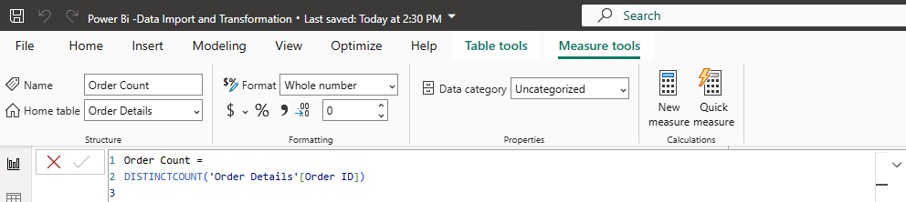

5. Average Profit in Delhi (Measure) :
Formula : Average Profit in Delhi =CALCULATE (
AVERAGE('Order Details'[Profit]),
'List of Orders'[City]="Delhi"
)

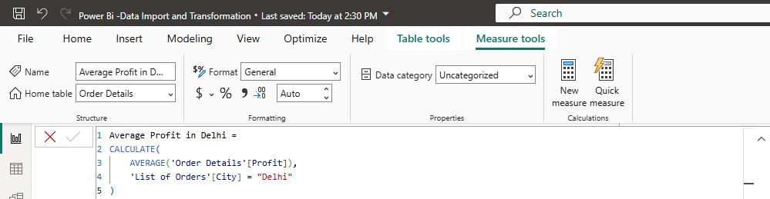

Description:
Calculates the average profit generated from orders placed in Delhi.

6. YTD Sales (Measure) :
Formula : YTD Sales =
TOTALYTD (
SUM('Order Details'[Amount]),
'List of Orders'[Order Date]
)

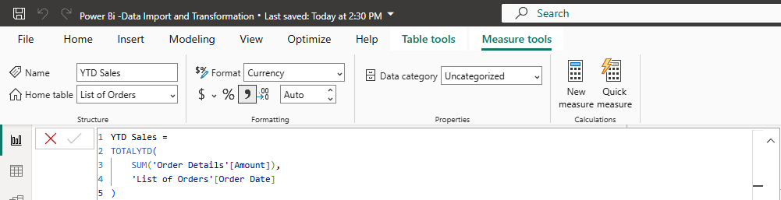

Description:
Calculates cumulative sales from the beginning of the year.
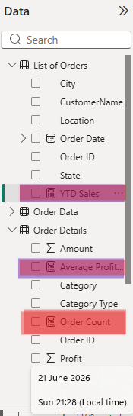

DASHBOARD ANALYSIS AND INSIGHTS

1. Sales Target Achievement by Category:
Observation:
- Clothing Sales: 174K
- Clothing Target: 139K
- Electronics Sales: 129K
- Electronics Target: 165K
- Furniture Sales: 133K
- Furniture Target: 127K
Insights:
- Clothing exceeded its target by approximately 35K.
- Furniture slightly exceeded its target.
- Electronics failed to achieve its target.
Business Recommendation:
Increase promotional activities and sales strategies for Electronics products.

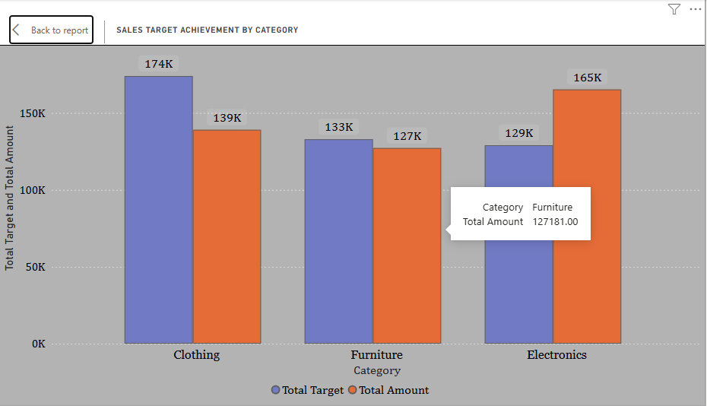

2. Maximum Profit Margin by Sub-Category:
Insights:
- Handkerchief contributes the highest profit margin.
- T-Shirt and Stole are also high-performing sub-categories.
- Some products contribute minimally to overall profitability.
Business Recommendation:
Focus marketing efforts on high-margin products.

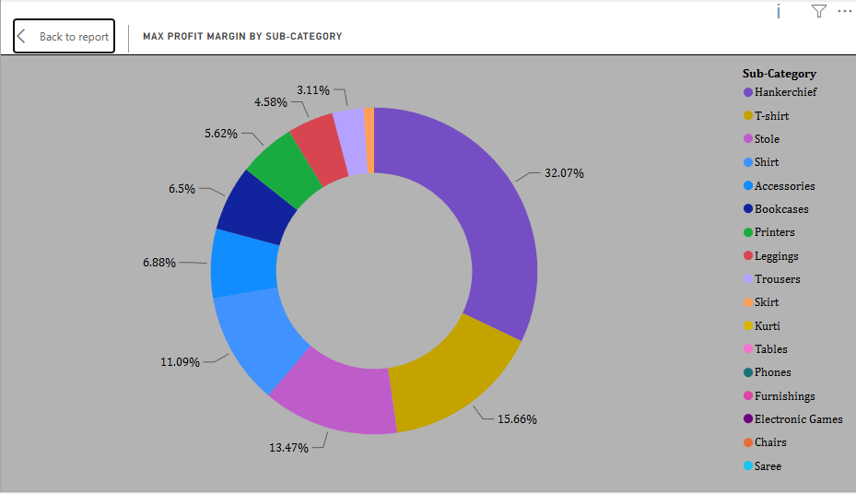

3. Monthly Sales Trend:
Observation:
- Highest Sales: January (61K)
- Second Highest: March (59K)
- Lowest Sales: July (13K)
Insights:
Sales exhibit seasonal fluctuations throughout the year.
Business Recommendation:
Introduce discounts and promotional campaigns during low-performing months.

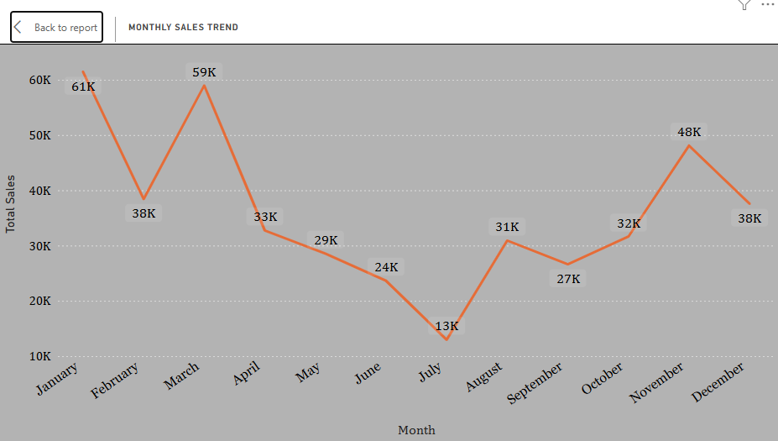

4. Profit vs Quantity Analysis:
Insights:
- Higher sales volumes do not always result in higher profits.
- Some products generate high profits despite low quantities sold.
Business Recommendation:
Focus on products that deliver better profit margins rather than only high sales volume.

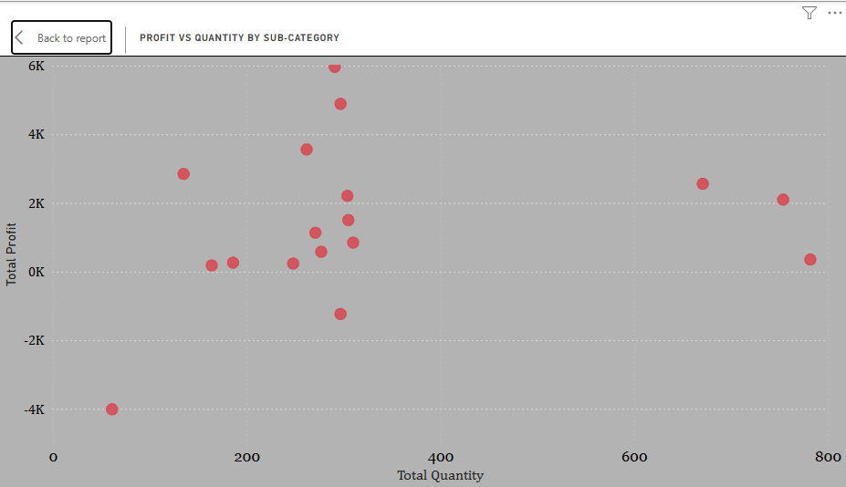

5. Total Sales Amount vs Total Target:
Observation:
- Total Sales Amount: 431.50K
- Total Target: 435.90K
Insights:
The company narrowly missed its overall target by approximately 4.4K.
Business Recommendation:
Minor improvements in sales strategies can help the company achieve future targets.
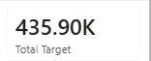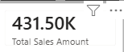
6. Minimum Target by Category:
Observation:
- Clothing: 12,000
- Furniture: 10,400
- Electronics: 9,000
Insights:
Electronics has the lowest minimum target among all categories.

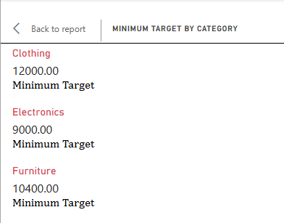

7. Sales Performance Matrix:
Insights:
The matrix enables month-wise and category-wise performance comparison and helps identify underperforming periods.
Business Recommendation:
Use matrix insights to forecast future sales and optimize business planning.
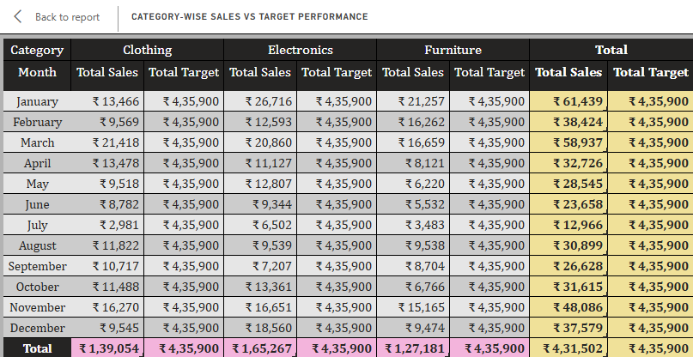

8. Geographic Sales Analysis:
Insights:
Sales are concentrated in a few key cities.
Business Recommendation:
Expand marketing campaigns in high-performing regions and improve sales in underperforming locations.

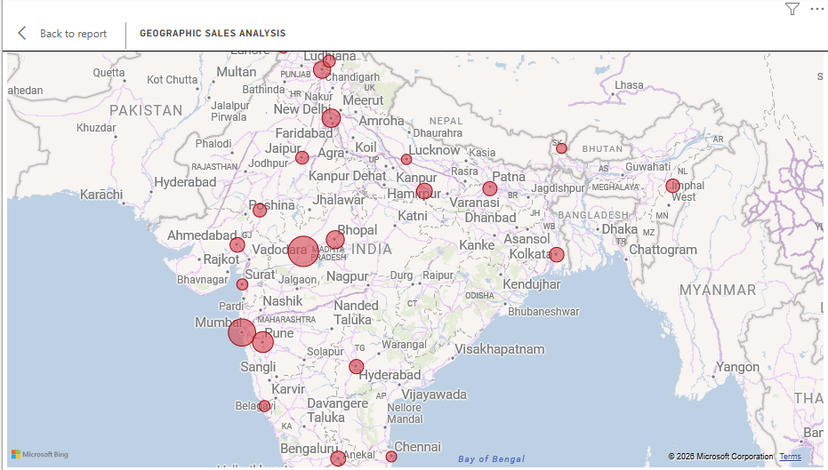

9. Sales Distribution by Sub-Category:
Insights:
The highest sales contribution comes from:
- Printers
- Phones
- Bookcases
- Sarees
Lower contribution comes from:
- Skirts
- Leggings
- Kurtis
Business Recommendation:
Maintain sufficient inventory for high-performing products and improve marketing strategies for low-performing products.

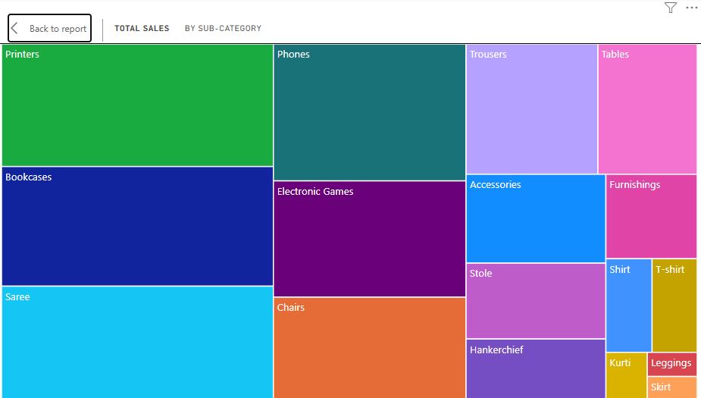

Order Count Analysis by State:
Insights:
- Some states contribute a higher number of orders than others.
- A few states account for the majority of customer orders.
- Several states have relatively low order volumes.
Business Recommendation:
- Focus on retaining customers in high-order states.
- Increase marketing efforts in low-performing states.
- Develop region-specific strategies to improve order volumes and expand market reach.

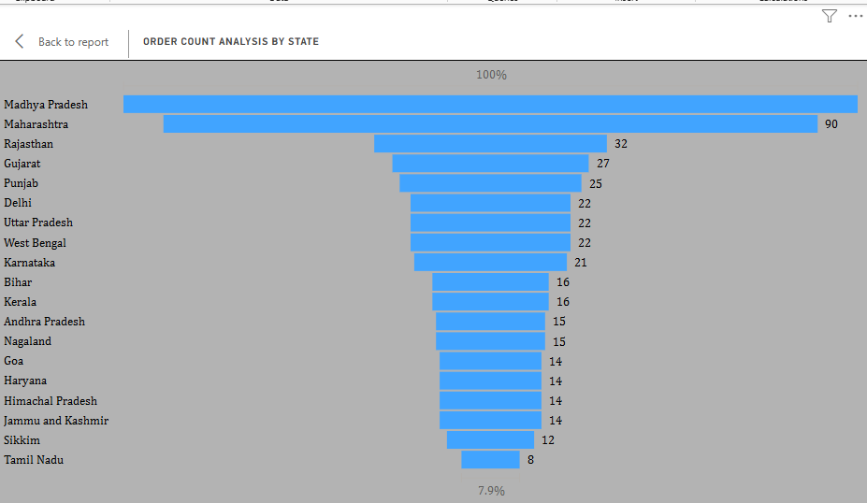

OVERALL BUSINESS INSIGHTS:
- Clothing is the best-performing category.
- Electronics requires improvement to achieve sales targets.
- January and March are peak sales months.
- July is the weakest sales month.
- A few sub-categories contribute most of the revenue and profit.
- The company narrowly missed achieving its overall sales target.
- Geographic analysis helps identify potential markets for expansion.
CONCLUSION:
This project successfully demonstrates the use of Power BI and DAX to transform raw e-commerce data into meaningful business insights. The dashboard enables stakeholders to monitor sales performance, evaluate profitability, compare actual sales with targets, and make data-driven decisions for future business growth.

Tools Used:
- Microsoft Power BI Desktop
- Power Query Editor
- DAX (Data Analysis Expressions)
- Data Modelling and Visualization Techniques

FINAL DASHBOARD SUMMARY
Key Insights:
- Clothing exceeded its sales target, while Electronics failed to achieve its target.
- January and March recorded the highest sales, whereas July had the lowest sales.
- Handkerchief, T-Shirt, and Stole generated the highest profit margins.
- Higher sales quantity does not always result in higher profits.
- The company narrowly missed its overall sales target by approximately 4.4K.
- Sales are concentrated in a few major cities, indicating strong regional markets.
- Printers, Phones, Bookcases, and Sarees contributed the highest sales among all sub-categories.
- Madhya Pradesh and Maharashtra recorded the highest number of orders, while Tamil Nadu had comparatively fewer orders.
Business Recommendations:
- Increase promotional activities for Electronics to improve target achievement.
- Implement special offers during low-performing months to boost sales.
- Focus on high-margin and high-selling products by maintaining adequate inventory.
- Develop targeted marketing strategies for low-performing products and regions.
- Strengthen customer engagement in high-order states and expand market presence in underperforming states.
- Use dashboard insights to improve forecasting, inventory management, and strategic decision-making.

Conclusion:
The Power BI dashboard provides a comprehensive view of sales performance, profitability, customer demand, and regional trends. The insights generated from this analysis can help the business make informed decisions, improve sales strategies, and achieve sustainable growth.

